***PIZZA SALE ANALYSIS***

***SQL QUERYS***

**Q1.TOTAL REVENUE:-**

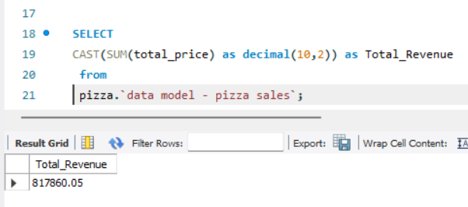

**Q2.Average Oder Value:-**

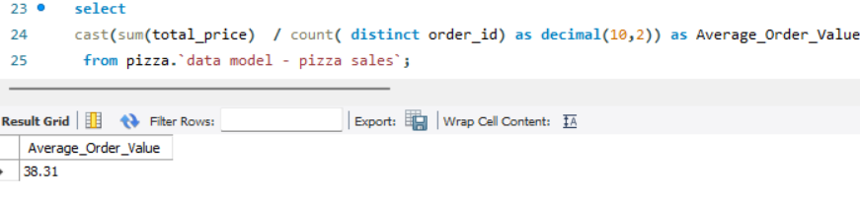

**Q3.Total Pizza Sales:-**

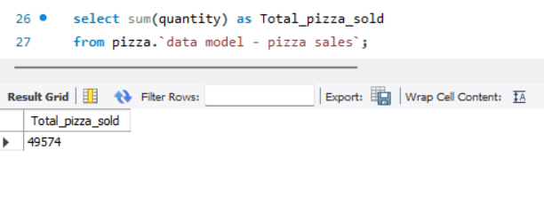

**Q4.Total Orders:-**

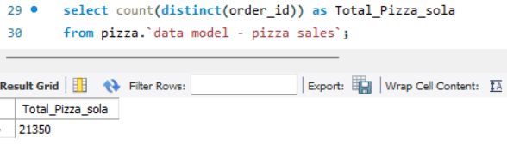

**Q5. Average Per day:-**

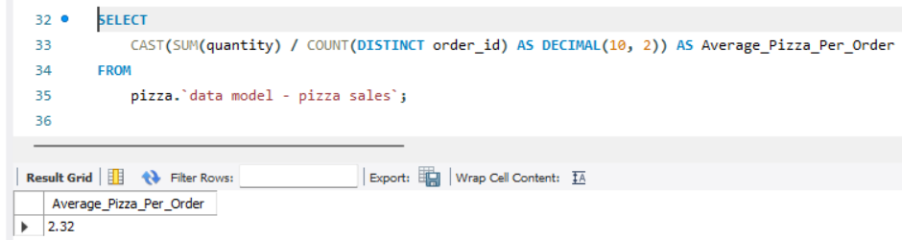

**Q6. Total Revenu Per_day: -**

**Q7.% of Sales by Pizza Size:-**

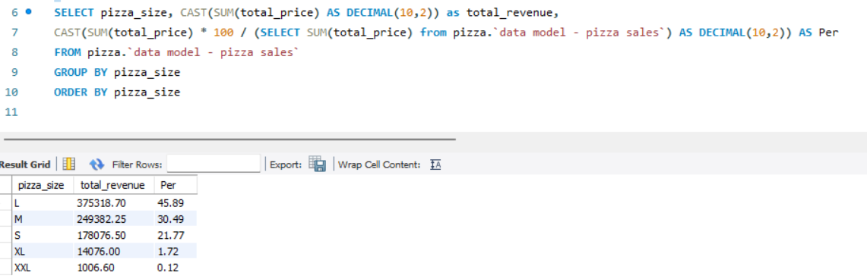**Q8.Total Pizzas Sold by Pizza Category:-**

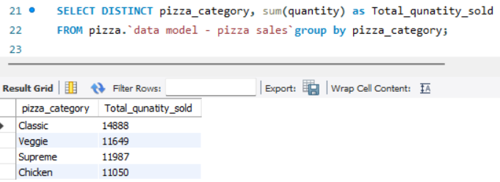

**Q9. Top 5 Pizzas by Revenue:-**

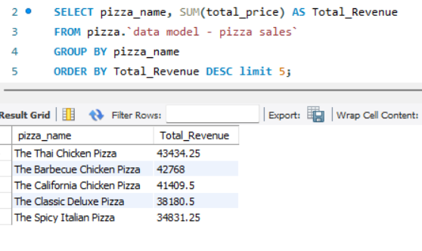

**Q10.Bottom 5 Pizzas by Revenue:-**

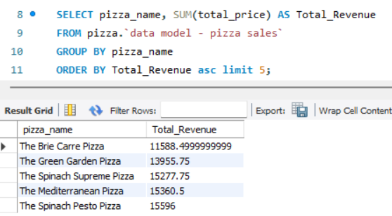

**Q11.Top 5 Pizzas by Quantity:-**

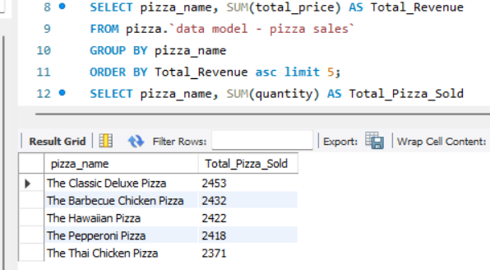

**Here’s a set of explanations based on the provided SQL queries. Each query’s purpose and importance in analyzing pizza sales are outlined clearly:**

**1. Total Revenue**

This query calculates the total income generated by all pizza sales. It sums up the product of quantity sold and the price per pizza across all orders. Understanding total revenue is critical for assessing the overall business performance and identifying growth trends.

**2. Average Order Value**

This query computes the average revenue generated per order. It divides the total revenue by the total number of orders. Average order value helps evaluate customer purchasing behavior and the effectiveness of sales strategies**.**

**3. Total Pizza Sales**

This query aggregates the total number of pizzas sold. By summing up the quantities, this metric provides insights into customer demand and helps in inventory planning**.**

**4. Total Orders**

This query counts the total number of orders placed. Tracking the total orders over time can reveal customer engagement levels and order frequency trends.

**5. Average Sales Per Day**

This query calculates the average number of pizzas sold daily. By dividing the total sales by the number of days in the dataset, businesses can understand daily performance and seasonal demand patterns.

**6. Total Revenue Per Day**

This query determines the average daily income from sales. It helps in setting revenue targets and measuring how consistent daily sales are with long-term goals**.**

**7. Percentage of Sales by Pizza Size**

This query evaluates the distribution of sales across different pizza sizes (e.g., Small, Medium, Large). Understanding the popularity of sizes helps tailor marketing strategies and optimize menu pricing**.**

**8. Total Pizzas Sold by Pizza Category**

This query breaks down the total sales by pizza category (e.g., Veg, Non-Veg, Specialty). It highlights customer preferences and assists in deciding which categories need promotion or improvement**.**

**9. Top 5 Pizzas by Revenue**

This query identifies the highest-earning pizzas. Knowing which pizzas generate the most revenue helps in menu optimization and focused promotions**.**

**10. Bottom 5 Pizzas by Revenue**

This query highlights the pizzas contributing the least to revenue. It can guide decisions on discontinuing underperforming items or redesigning them to increase appeal**.**

**11. Top 5 Pizzas by Quantity Sold**

This query finds the pizzas with the highest sales volume. It identifies customer favorites, which can be emphasized in advertising or included in combo deals.

These explanations can help team members or stakeholders understand the purpose of each query and how the data analysis aids in business decision-making**.**